[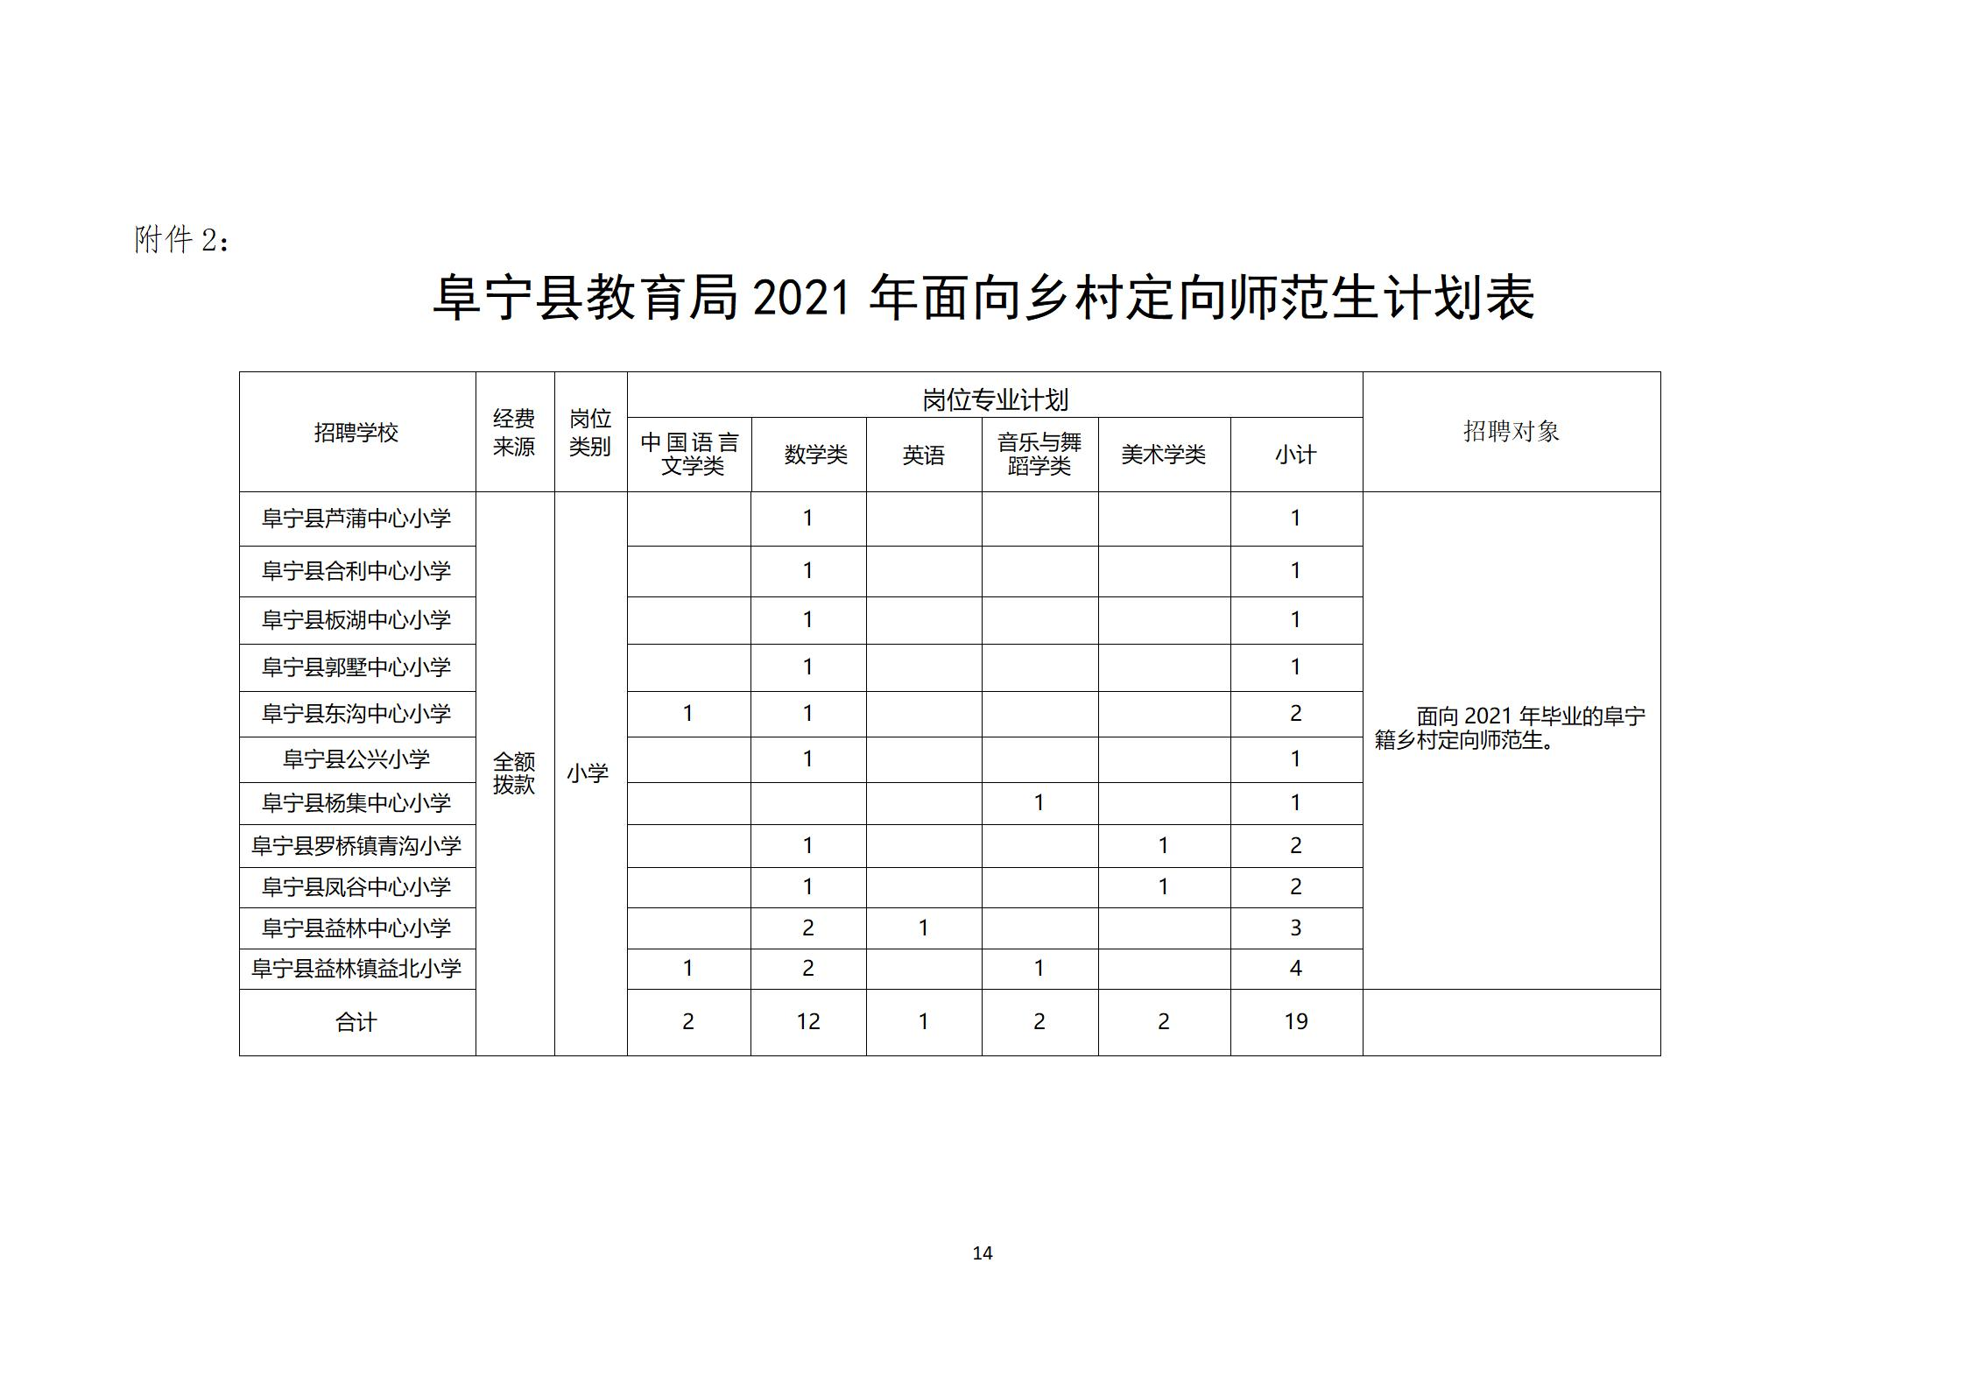](http://www.funing.gov.cn/picture/0/40d2b7f5b3914baa875ee667d2a6e4b9.jpg)[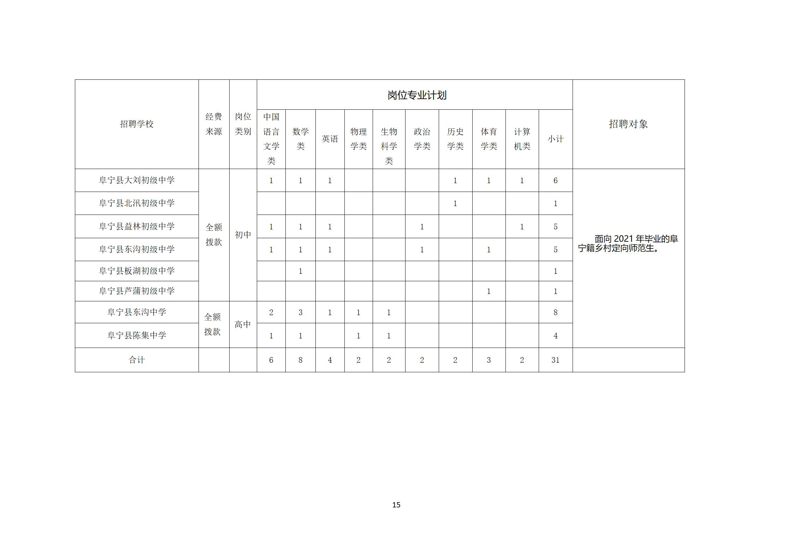](http://www.funing.gov.cn/picture/0/6ca027d8c8404e268f4fa34e5cda9bde.jpg)[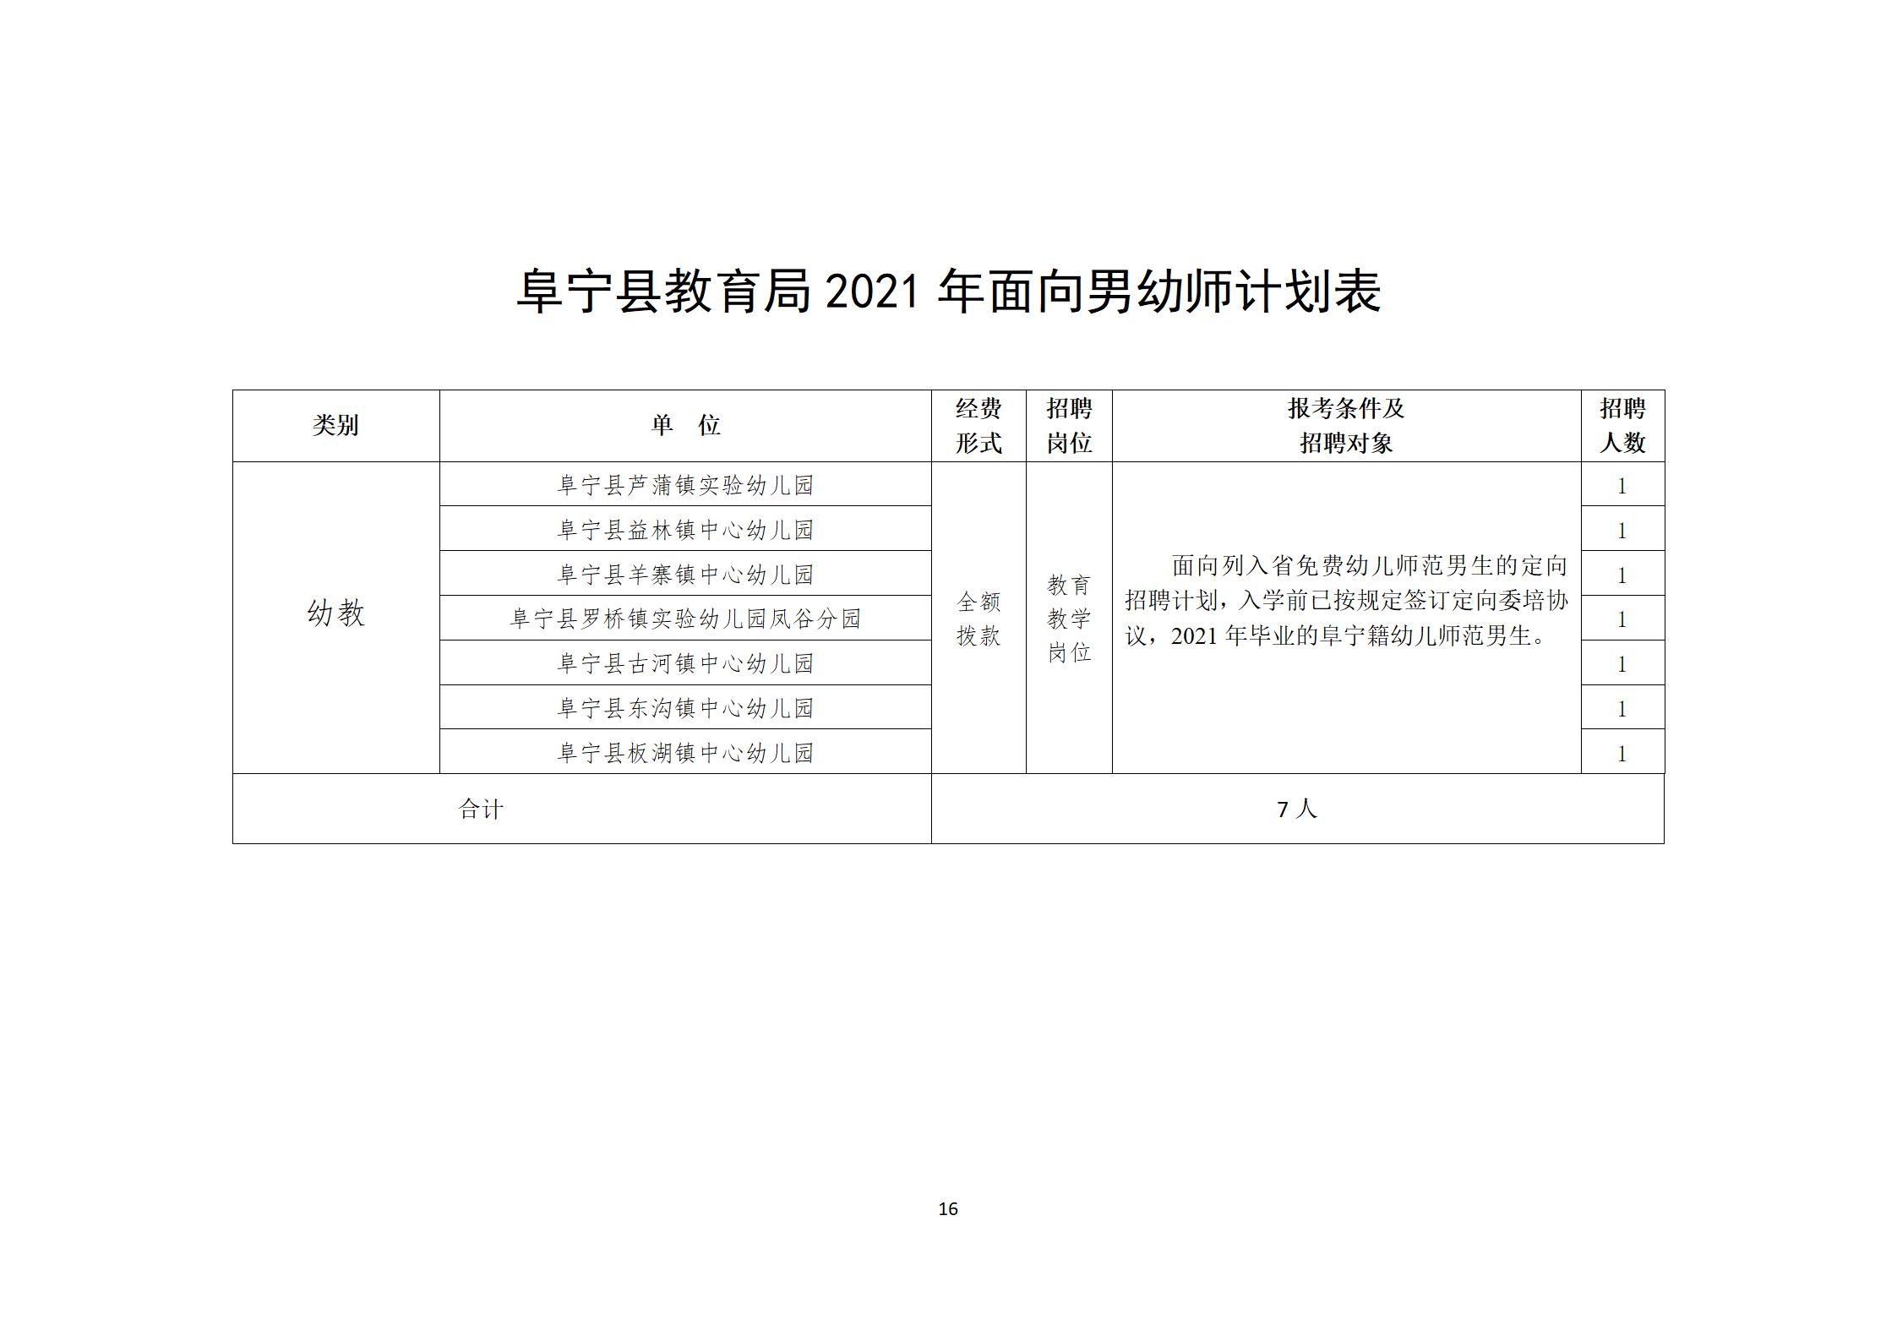](http://www.funing.gov.cn/picture/0/e2d7a245e2e44b9c9d7c234b377f74ea.jpg)